- Boat Supply
We love our boat as much as you

We can supply any type of boat as per your requirements. Just knock us and see how we meet your requirements.

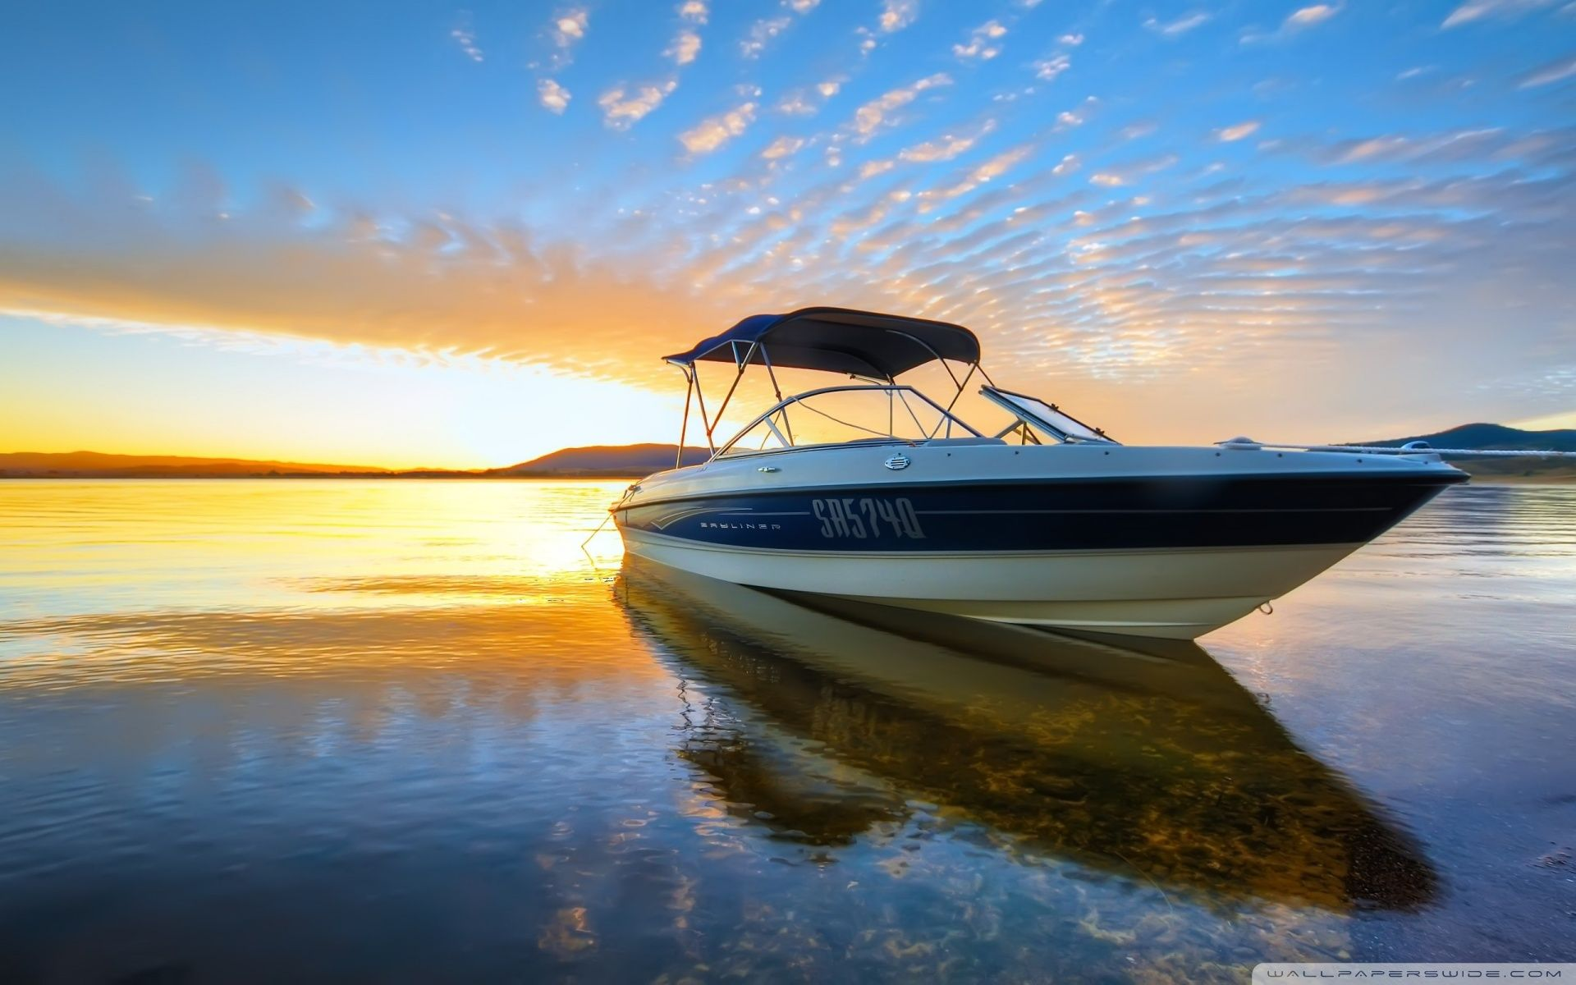

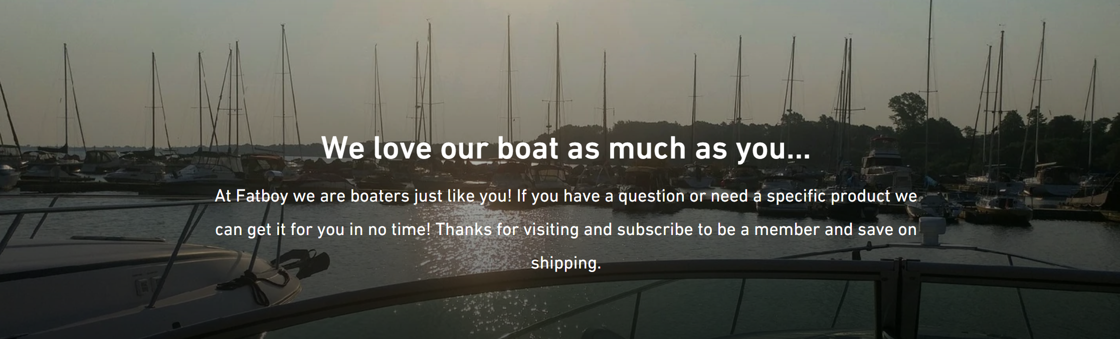

- Marine Engine Supply

We have the most complete and modern engine supplier connection in Canada. We can link and supply the complete marine gas and diesel engine for Domestic and International use.

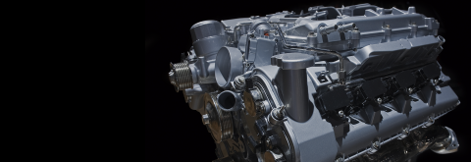

- Marine Parts Supply
Connection Hub Marine Parts assure the Best price guaranteed! Call us or email us and we will price match or beat any price! We can connect the best supplier for quality marine engine parts and accessories worldwide.

